PRACTICAL 5A
(Docker Containers)
Aim: To create a Docker image for hosting a Hello World Express.js application

Requirements
- Docker Desktop with WSL enabled
- To enable/install WSL (Windows Subsystem for Linux) type: ~ “wsl install “in cmd
- Node.js and npm
- Visual Studio Code

Step 1: Create Project Folder
Create a folder named docker and open it in VS Code.
In Terminal type this Commands:
npm init -y // for initializing node environment in folder
npm install express

Step2: Create a Server.js file
code:
'use strict';

const express = require('express');

const PORT = 8080;
const HOST = '0.0.0.0';

const app = express();

app.get('/', (req, res) => {
res.send('Hello World');
});

app.listen(PORT, HOST, () => {
console.log(`Running on http://${HOST}:${PORT}`);
});

Step3: Create A Dockerfile named “Dockerfile”
FROM node:18

WORKDIR /usr/src/app

COPY package*.json ./

RUN npm install

COPY . .

EXPOSE 8080

CMD ["node", "server.js"]

Step4: Create a .dockerignore file
node_modules
npm-debug.log

Step5: Recode the existing package.json file

{
"name": "hello-world-express",
"version": "1.0.0",
"description": "A Dockerized Express.js Hello World app",
"main": "server.js",
"scripts": {
"start": "node server.js"
},
"dependencies": {
"express": "^4.19.2"
}
}

and reinitialize npm `npm install` in vs terminal

Step 5: Build Docker Image
docker build -t node-web-app .

Step 6: Run Docker Container
docker run -d -p 8080:8080 --name my-node-app node-web-app

Step 7: Verify
docker ps
docker logs my-node-app
Open http://localhost:8080 in a browser.

Output:
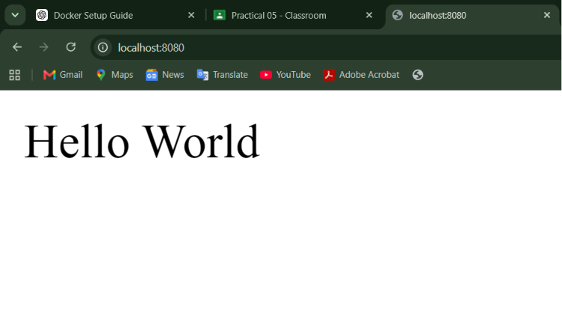

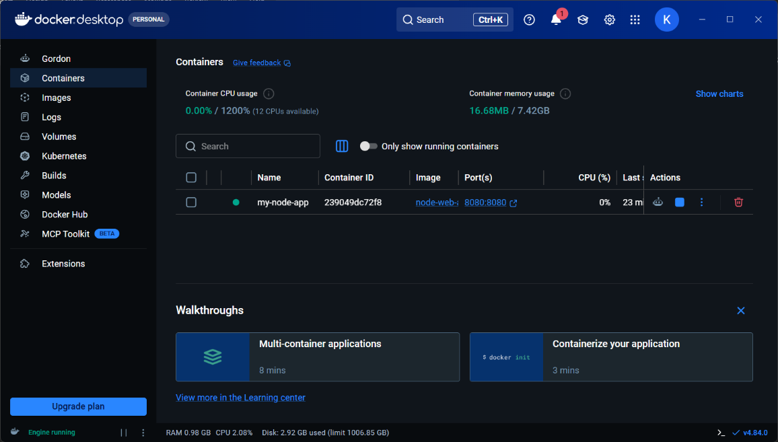
PRACTICAL 5B
(Docker Containers)
Aim: Create a multi-stage Dockerfile for a production-ready ExpressJS application to minimize image size and remove development dependencies.

Step 1: Create a Project Folder

mkdir express-app
cd express-app

Step 2: Initialize the Node.js Project
npm init -y

Step 4: Create server.js

Paste the following code:
const express = require("express");

const app = express();
const PORT = 8081;

app.get("/", (req, res) => {
res.send("Hello Express!");
});

app.listen(PORT, () => {
console.log(`Server running on port ${PORT}`);
});

Step 5: Create .dockerignore
.dockerignore
Paste:
node_modules
npm-debug.log

Step 6: Create Dockerfile
Dockerfile
Paste:
# ---------- Build Stage ----------
FROM node:18-alpine AS builder

WORKDIR /app

COPY package*.json ./

RUN npm install

COPY . .

# ---------- Production Stage ----------
FROM node:18-alpine

WORKDIR /app

COPY package*.json ./

RUN npm install --omit=dev

COPY --from=builder /app .

EXPOSE 8081

CMD ["node","server.js"]

Step 7: Check the Project Files
dir
You should have:
Dockerfile
.dockerignore
package.json
package-lock.json
server.js
node_modules

Step 8: Build the Docker Image

docker build -t express-production .

Step 9: Check the Docker Image
docker images
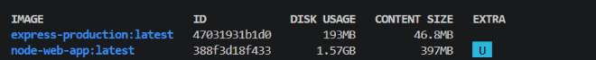

Step 10: Run the Docker Container

docker run -d -p 8081:8081 --name expressapp express-production

Step 11: Verify the Container
docker ps

Step 12: Open the Application
Open your browser:
http://localhost:8081

OUTPUT:
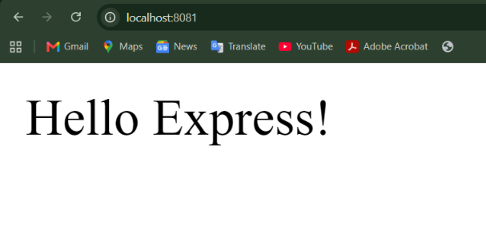
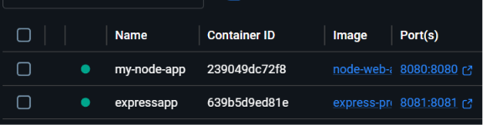
PRACTICAL 5C
(Docker Containers)
Aim: To create and configure a Docker Compose setup that runs an ExpressJS application container alongside a MongoDB database container with persistent data storage using Docker volumes.

Step 1: Create a Project Folder
mkdir express-compose
cd express-compose

Step 2: Initialize Node.js
npm init -y

Step 3: Install Required Packages
npm install express mongoose

Step 4: Create server.js
const express = require("express");
const mongoose = require("mongoose");

const app = express();
const PORT = 8082;

mongoose.connect("mongodb://mongodb:27017/mydatabase")
.then(() => console.log("MongoDB Connected"))
.catch(err => console.log(err));

app.get("/", (req, res) => {
res.send("Hello from ExpressJS with MongoDB");
});

app.listen(PORT, () => {
console.log(`Server running on port ${PORT}`);
});

Step 5: Create .dockerignore
node_modules
npm-debug.log

Step 6: Create Dockerfile
FROM node:18-alpine

WORKDIR /app

COPY package*.json ./

RUN npm install

COPY . .

EXPOSE 8082

CMD ["node", "server.js"]

Step 7: Create docker-compose.yml
version: "3.9"

services:
app:
build: .
container_name: express-compose-app
ports:
- "8082:8082"
depends_on:
- mongodb
restart: always

mongodb:
image: mongo:7
container_name: mongodb
ports:
- "27017:27017"
volumes:
- mongo-data:/data/db
restart: always

volumes:
mongo-data:

Step 8: Verify Files
dir
You should have:
Dockerfile
docker-compose.yml
.dockerignore
package.json
package-lock.json
server.js

Step 9: Build the Containers
docker compose build

Step 10: Start the Containers
docker compose up -d

Step 11: Verify Running Containers
docker ps
You should see:
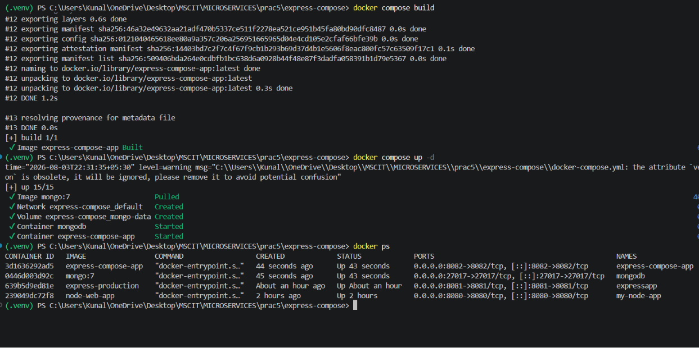

Step 12: Test the Application
Open your browser:
http://localhost:8082
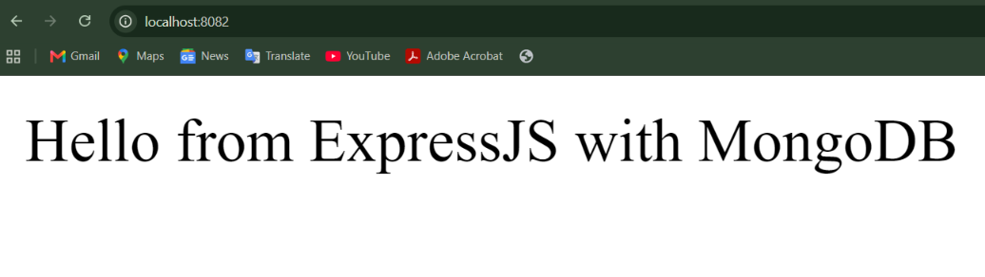

Step 13: View Logs
ExpressJS container:
docker logs express-compose-app
MongoDB container:
docker logs mongodb

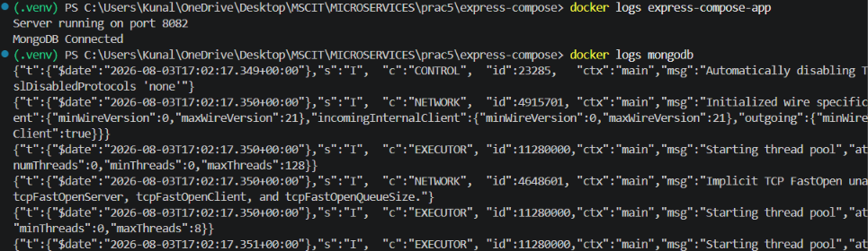
Docker View
